General Welfare Requirement: Documentation
Providers must maintain records, policies and procedures required for the safe and efficient management of the settings and to meet the needs of the children.
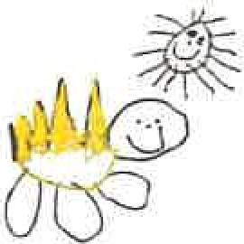
Gorran Pre School
Record keeping
5.3 Transfer of records to school
Policy statement
We recognise that children sometimes move to another early years setting before they go on to school although many will leave our setting to enter a nursery or reception class.
We prepare children for these transitions and involve parents and the receiving setting in this process. We prepare records about a child's development and leaming in the EYFS in our setting; in order to enable smooth transitions we share appropriate information with the receiving setting or school at transfer.
Confidential records are shared where there have been child protection concerns according to the process required by our Local Safeguarding Children Board.
The procedure guides this process and determines what information we can and cannot share with a receiving school or setting.
EYFS key themes and commitments
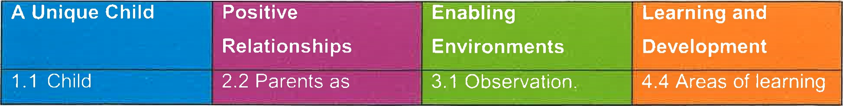
development  1 .2 Inclusive  Practice  1 .3 Keeping safe  1 .4 Health and wellbeing | partners  2.3 Key person | Assessment and  Planning  3.2 Supporting every  3.4 The wider context | And development

Procedures
Transfer of development records for a child moving to another eaHy years setting or school Using the EYFS assessment of development and learning ensure the key person prepares a summary of achievements in the six areas of learning.
- This record refers to any additional language spoken by the child and his or her progress in both languages.
The record also refers to any additional needs that have been indentified or addressed by the setting.
The record also refers to any special needs or disability and whether a CAF was raised in respect of special needs or disability, whether there is a Statement of Special
Educational Needs and gives the name of the lead professional.
- The record contains a summary by the key person and a summary of the parent's view of the child.
The document may be accompanied by other evidence such as photos or drawings that the child has made.
For transfer to school, most local authorities provide an assessment summary format or a transition record for the setting to follow.
If there have been any welfare or protection concerns a star is placed on the front of the assessment record.
Transfer of confidential information
The receiving school or setting will need to have a record of concerns that were raised in the setting and what was done about them.
A summary of the concerns will be made to send to the receiving setting or school along with the date of the last professional meeting or case conference. Some Local
Safeguarding Children Boards will stipulate the forms to be used and provide these. Where a CAF has been raised in respect of any welfare concerns the name and contact details of the lead professional will be passed on to the receiving setting or school.
Where there has been a s47 investigation regarding a child protection concem the name and contact details of the child's social worker will be passed on to the receiving setting or school — regardless of the outcome of the investigation.
- This information is posted or taken to the school or setting, addressed to the setting or school's designated person for child protection and marked confidential.
Legal framework
- Data Protection Act 1998
- Freedom of Information Act 2000
- Human Rights Act 1998
- Children Act 1989
Further guidance
What to do if you are Worried a Child is Being Abused (HMG 2006)
Information Sharing: Guidance for Practitioners and Managers (DCSF 2008)
This policy was adopted at a meeting of Gorran Pre-School

Held on October 2019

Date to be reviewed October 2020

Signed on behalf of the management committee Michelle Beard

Name of signatory Michelle Beard

Role of signatory (e.g. chair/owner) Pre-School leader/Nominated Person

